Using Alfresco Zimlet

Overview

Alfresco Zimlet Package provides integration between Zimbra Collaboration Suite and Alfresco Enterprise Content Management (ECM) using Zimbra Zimlet technology, Alfresco Webscript technology and Yahoo YUI Javascript library.
Its key functionalities include
- Allowing user to manage Alfresco ECM server location and credentials as Zimlet preferences and managing security seamlessly.
- Allowing user to save attachments of incoming emails to Alfresco ECM server.
- Allowing user to select multiple documents from Alfresco ECM server and then attach them to outgoing emails.
- Allowing user to download documents from Alfresco ECM server or paste links to Alfresco documents directly into outgoing email body.
- Providing easy-to-use widgets for users to select Alfresco space or navigate through Alfresco repository.

Installation and Configuration

This integration package requires pre-installation of Zimbra Collaboration Suite (Version 5.0.6 or later) and Alfresco Enterprise Content Management (Version 2.1 or later). Once the package is installed, user need to provide location of Alfresco ECM server as well as user name and password for the Alfresco ECM server.
For more infromation regards to installation, configuration and validation, please refer to the “Alfresco Zimlet Installation Guide” document.

How to Use Alfresco Zimlet

Save Email Attachments to Alfresco ECM Server

The Alfresco Zimlet provides an additional attachment handler which renders “save to alfresco” link for each attachment of incoming emails. Users can simply click on the link and it will pops up a dialog asking for Title ( Pre-populated with the original file name of the attachment), Description (Optional input field) and Path of the Space where the attachment will be stored inside Alfresco ECM server.
The Space Path input field is an auto-complete style widget. Based on the user input, it will automatically generate a list of valid selections of Alfresco space paths for user to choose.
To start with root path of Alfresco ECM server, user can simple type / . If user prefers to start the browsing from his/her own home space, ~ is the character user needs to type.
Once user selects or types a space path and wants to continue exploring its subspaces, he/she can simple type / and the widget will show the list of paths of the subspaces.
Once all inputs are provided, click “Ok” button to save the attachment to Alfresco ECM server. The zimlet will first show the progress dialog and then the status dialog.

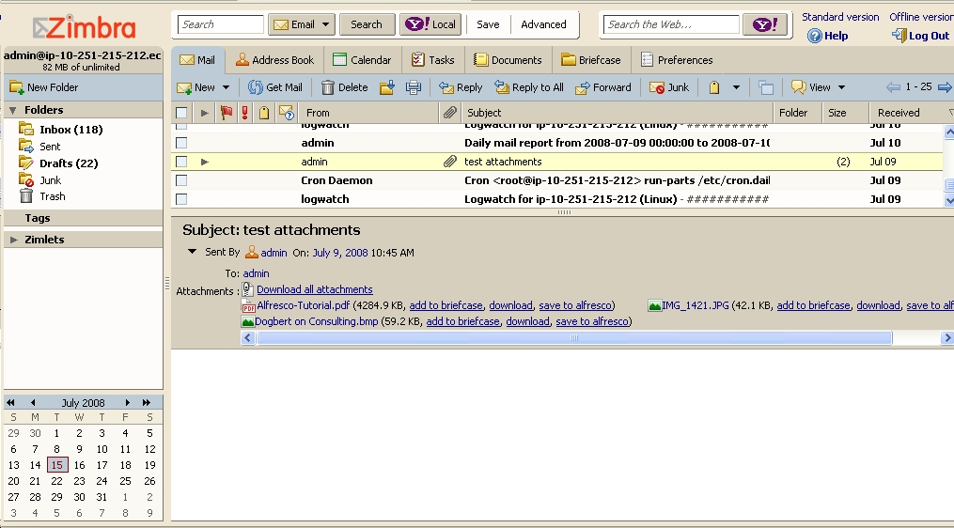
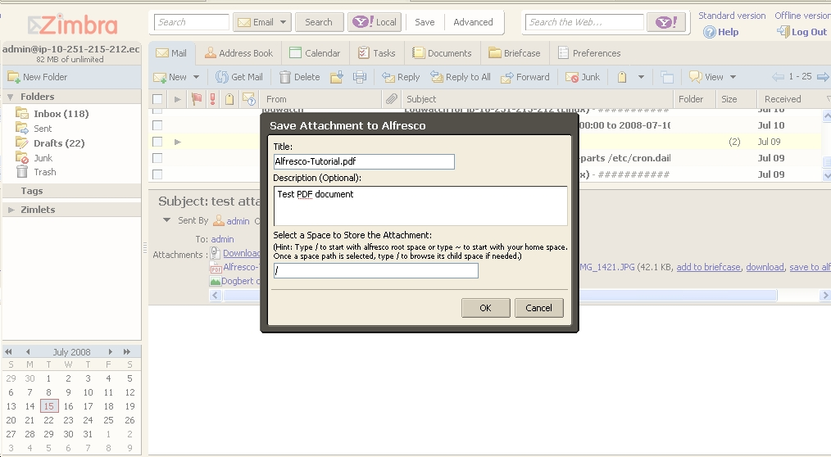

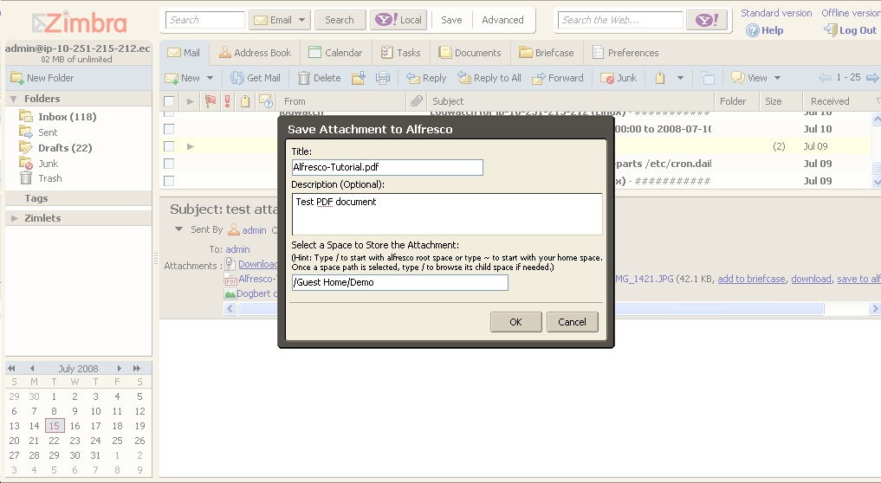
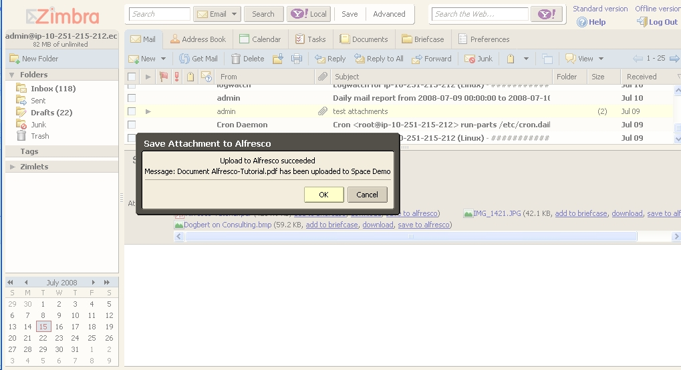

Attach Alfresco Documents to Email

